Casino Game : Propsal

Members: Ohad Badhav, Elizaveta Sidorova, Snir Ben Nissim

1. The Casino game is a multiplayer experience designed for players to either create their own gaming room or join an existing one. This platform facilitates collaborative gameplay, allowing users to come together and participate in a variety of engaging casino games.
2. Our project offers an added advantage centered around swiftly playing with your nearby friends using our location detection feature. This distinctive feature eliminates the need to add them to your friend list; instead, you can simply be in close proximity to them to join the game together seamlessly.
3. While some multiplayer casino games exist, many lack the ability for players to join rooms with their nearby friends. In other words, while they may facilitate multiplayer interactions, they often overlook the opportunity for players to easily connect with friends in their vicinity. This limitation can detract from the social aspect of the gaming experience, as players may prefer to engage in casino games with familiar faces or acquaintances nearby. By incorporating a feature that allows players to join their nearby friends' rooms, our game enhances the social dimension of the casino experience. This addition distinguishes our game from others in the genre, providing a more immersive and enjoyable multiplayer experience.
4. Our target users consist of groups who share an interest in casino games and prefer playing together. Additionally, individual players in proximity to others may spontaneously gather to enjoy gaming sessions collaboratively. The focal point of the game revolves around creating and joining rooms.

When creating a room, users are presented with a screen to select their preferred game, such as Poker or Blackjack, among others. Upon joining a room, users can browse a list of available options. Upon requesting to join a room, the room's creator receives a notification displaying the player's Avatar, name, and balance. The creator then has the discretion to accept or deny the request.

Upon opening the application, users encounter a login/sign-in screen. Room creators have the ability to stream the game on a separate screen, displaying relevant features for all players, while individual mobile devices showcase each player's unique features.

1. Our game boasts a diverse selection of casino games including Poker, Blackjack, Wheel of Fortune, and Horse Racing. Using our location detection feature, players can swiftly join games with their nearby friends, providing an authentic casino experience as they play alongside others at the same table/ same screen.

Top of Form

* The login/sign-in screen:

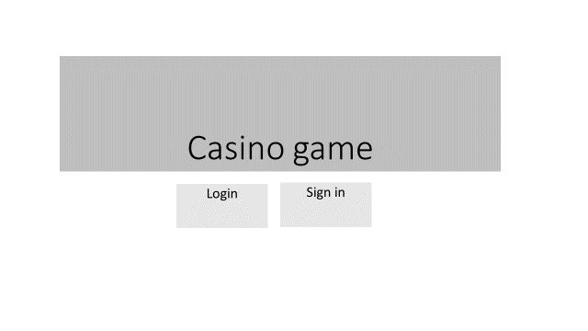

* 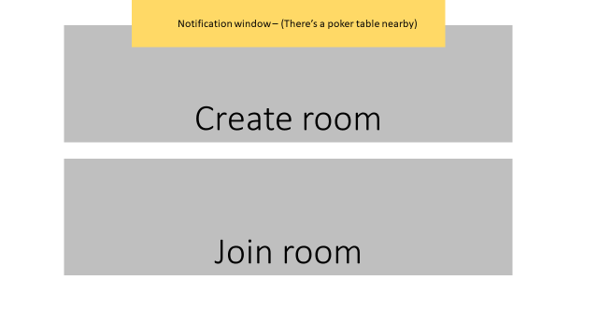The main screen:
* 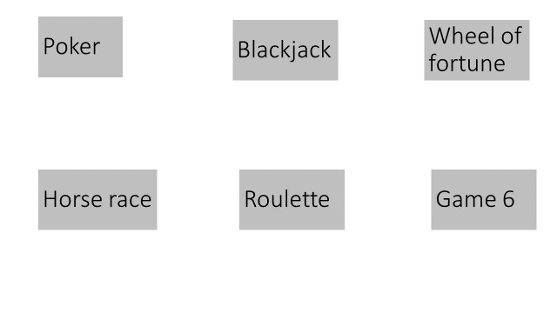The room creator:
* 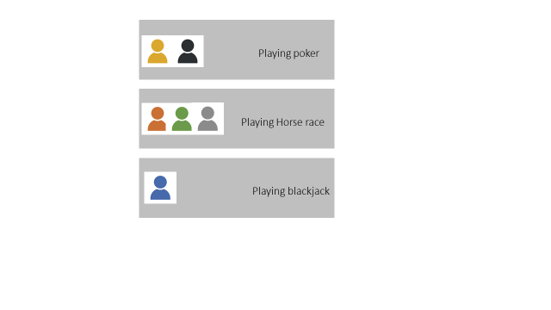The room join lobby:
* 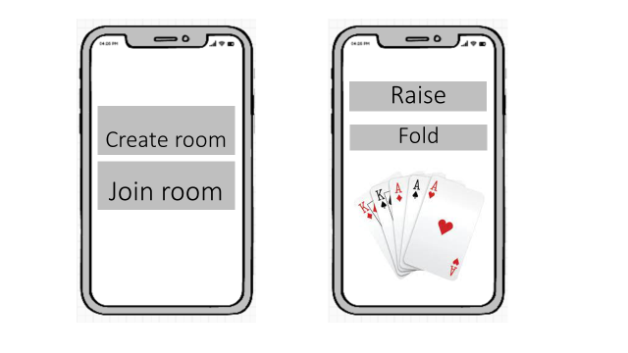The mobile view:
* 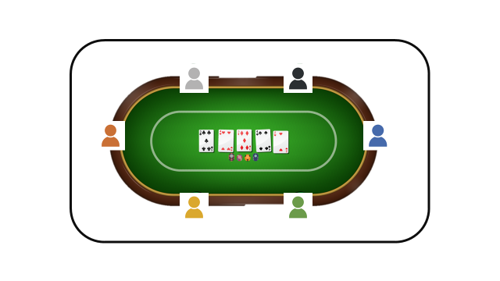The shared screen: